**Experiment1.1**

**Student Name: Suvigya Yadav UID:21BCS9206**

**Branch: BE-CSE Section/Group: CC-646 B**

**Date of Performance:16-01-2024 Semester: 6**

**Subject Name:** **Cloud Computing & Distributed Systems**

**Subject Code:** **21CSP-378**

1. **Aim:**

Install VirtualBox or VMware Workstation on a windows 7 or 8 Operating System and set up various flavors of Linux or Windows as virtual machines.

1. **Objective:**

To Install VirtualBox or VMware Workstation on a windows and set up various flavors of Linux or Windows as virtual machines.

1. **Steps to Install:**

Step 1: Download the virtual box

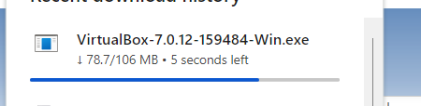

Step 2: once the virtual box is download now install it

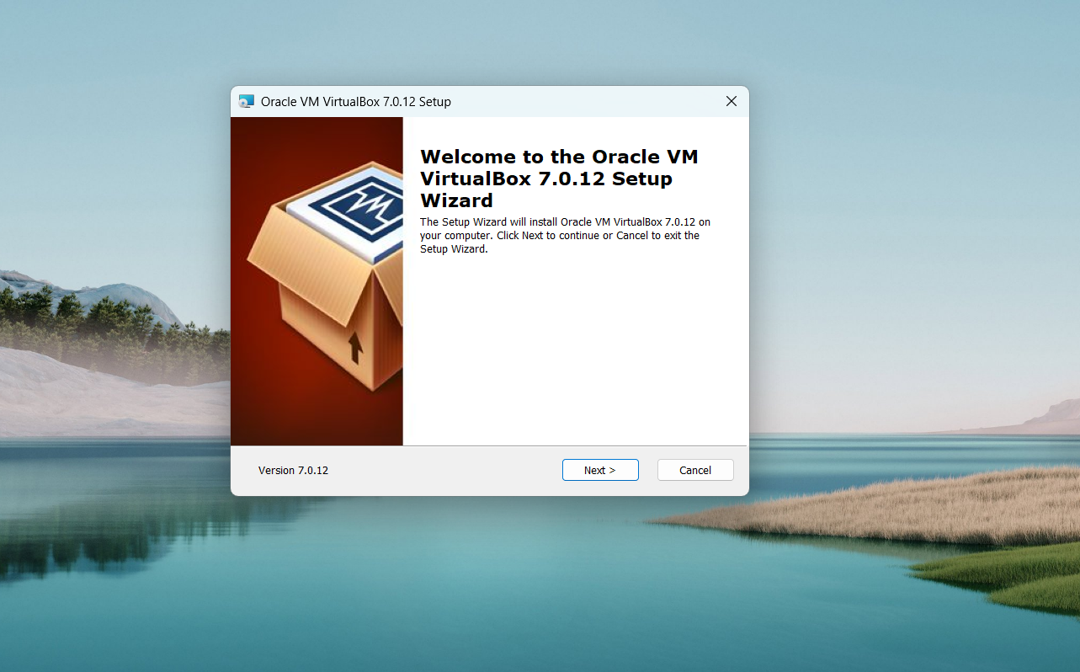

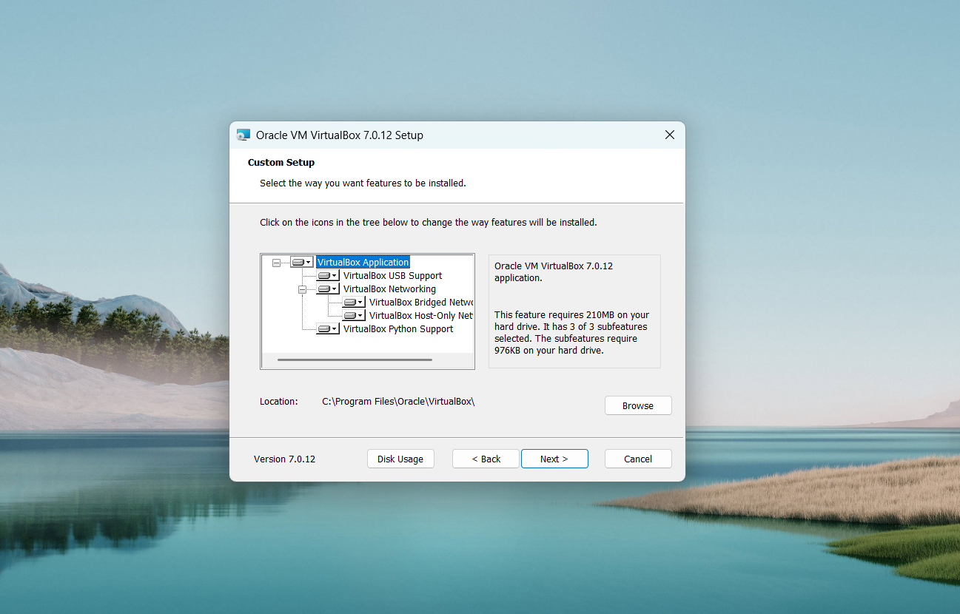

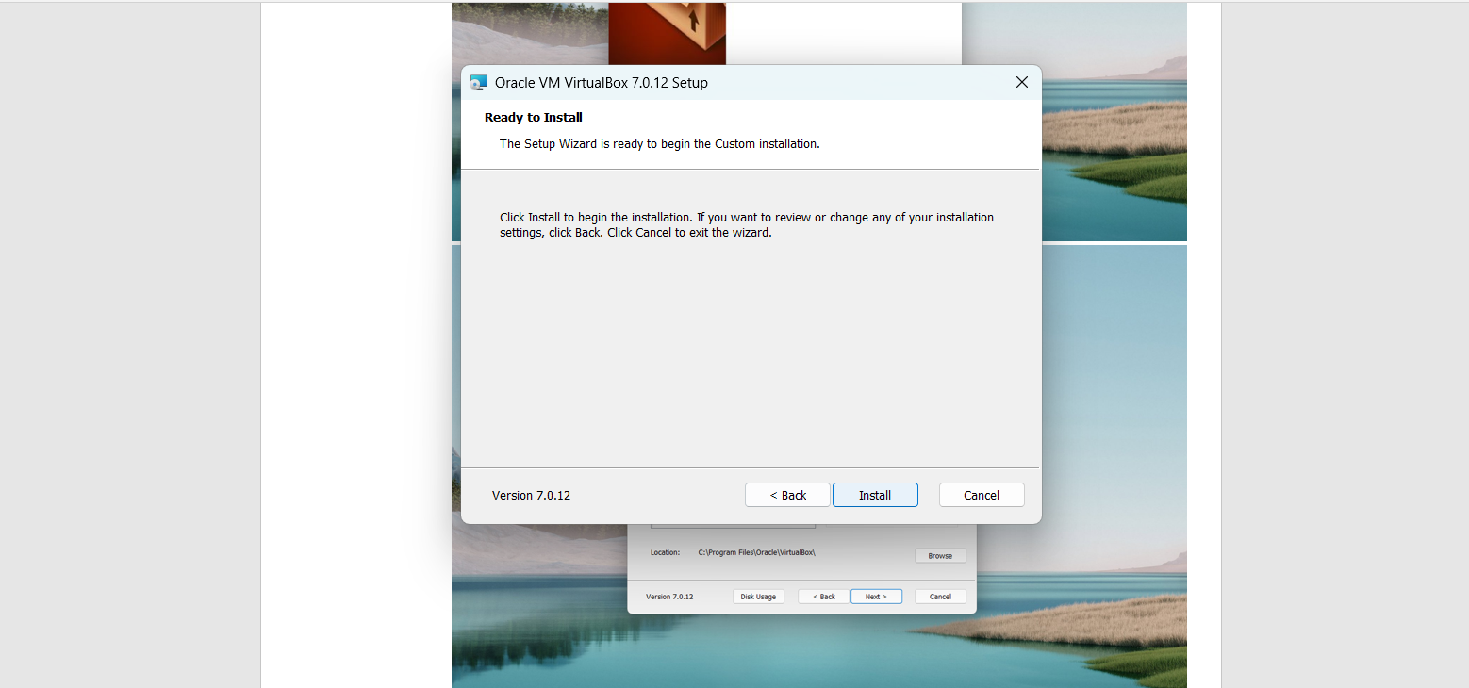

Step 3: once the virtual box is install click on new

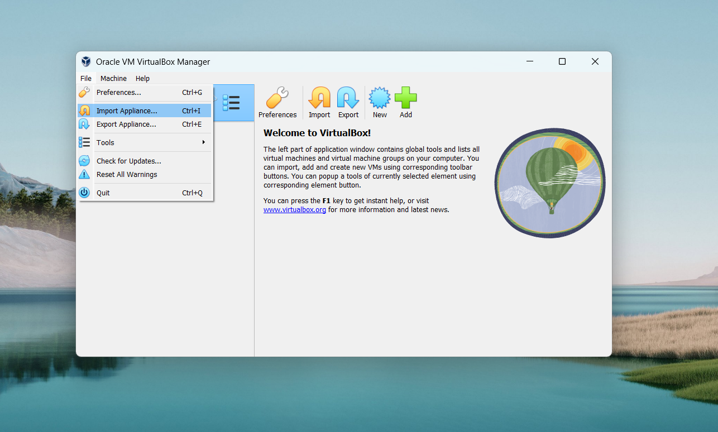

Step 4: Setup all the things with requirements

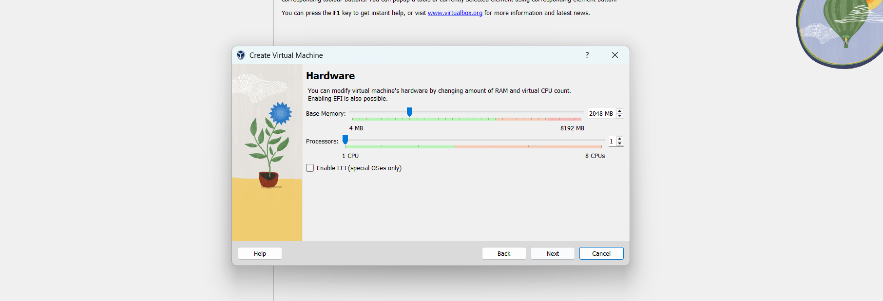

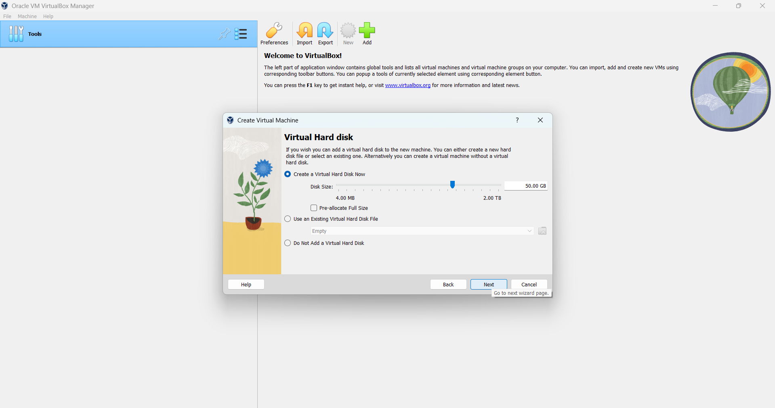

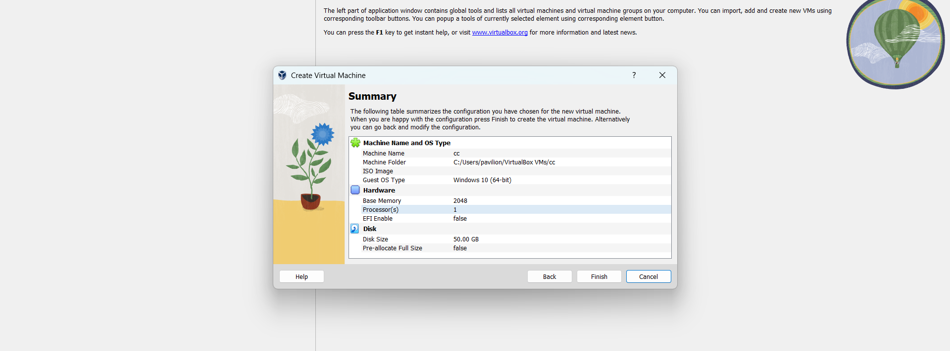

Step 5: here is the final screen

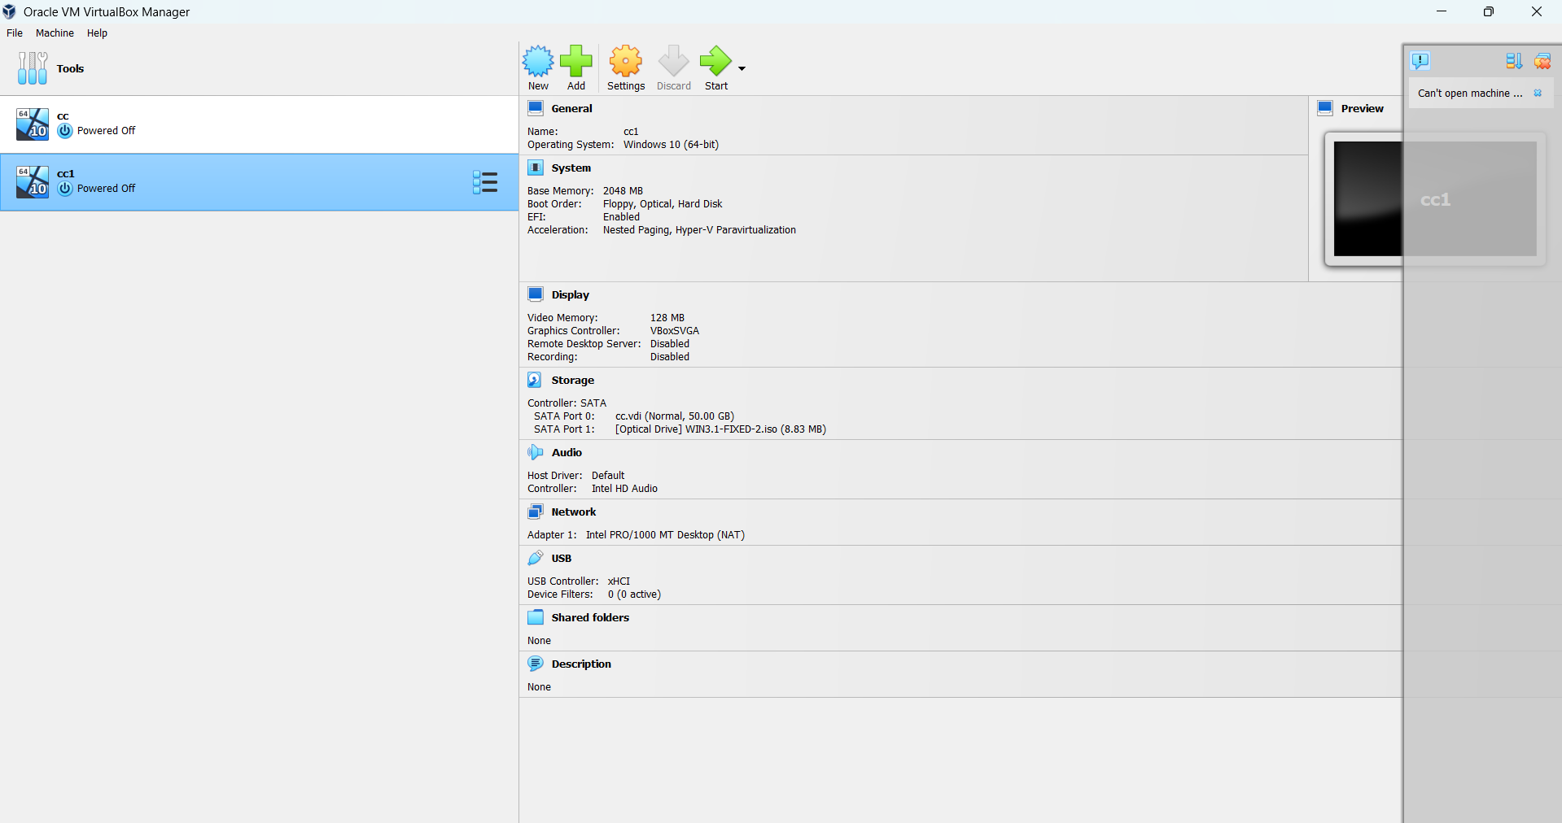

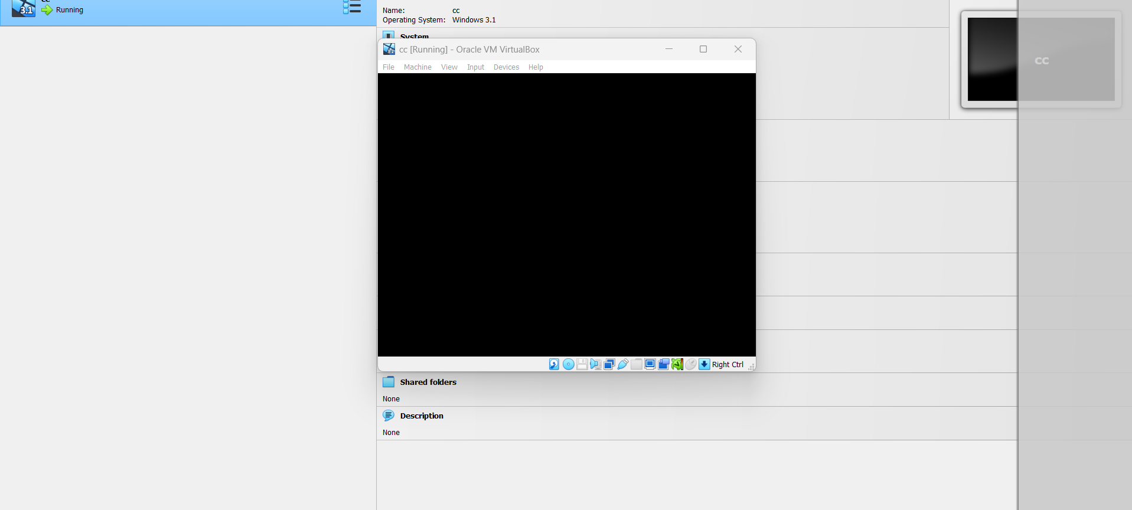

**Learning Outcome:**

* Learn how to install VirtualBox
* Understand the concept of Virtualization
* Understand how to create Virtual Machines
* Learned to manage and allocate the system resources like RAM, CPU and Disk Space for Virtual Machines.